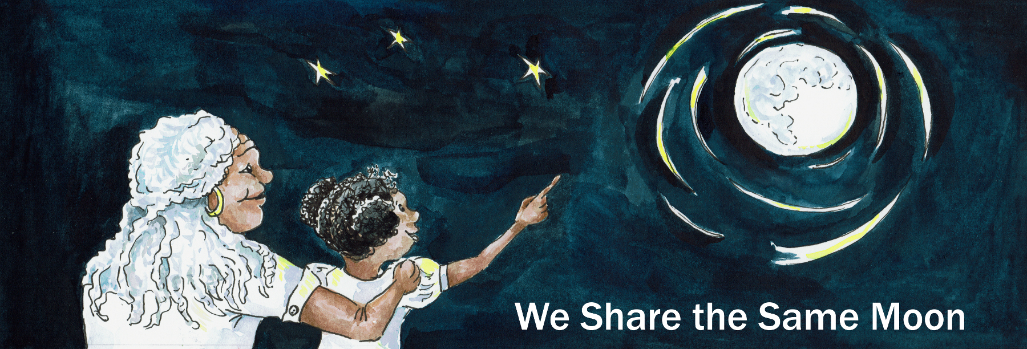
Suggested Age Range: 7 - 8 years; 8 - 9 years; 9 - 10 years; 10 - 11 years; 11 - 12 years; 12 - 13 years; 13 - 14 years; Adult
UK Curriculum: Key Stage Two (Lower) Key Stage Two (Upper)
Suggested UK Year Group: Year Three; Year Five
UK Primary Curriculum Link: Light; Earth and Space
Science Subject: Moon Phases
Science Question: Why does the Moon change shape?
Suggested Science Activity: Moon Phases
Children with SEND: Use to boost comprehension of science concepts
EAL children: For beginners
Country of Origin: Yaqui - people of Mexico
Source: Fiesta Feminista by Mary-Joan Gerson

The Sun and Moon light up our skies. The Sun’s golden rays fill the sky from dawn to dusk and then as the Sun begins to set, the Moon rises and takes his place, filling the sky with her silver light.
Every night as the Sun slides from the sky, he would look across at the Moon and sigh.
For you see, the poor Sun was lonely, up there in the sky.
The Moon has stars to talk to, but who does the Sun have? No-one.

Time passed and with every passing night, the Sun fell more and more in love with the Moon.
And so he decided to marry her so that they could shine together both day and night!

“What a good idea!” he thought.
But what about the Moon? What did she think of the idea of marriage?

Now the Moon, she rather liked to be by herself. If she was bored, there were Stars to talk to, Meteors to race against, planets to gossip to and giggle with.
Did she need or want a Husband? No!

And so when the Sun finally plucked up courage to tell of his adoration and endless love, she was ready with an answer!

“Marry me and be my love!” begged the Sun.
“Oh I would love to - but I can’t!” replied the Moon.

"Why not?” asked the Sun.
“Well you see, I cannot get married without a special dress to wear and nothing I wear ever seems to fit! I wouldn’t want to let you down at our wedding by being shabbily dressed. So, I cannot marry you - unless you make for me the perfect dress, that fits my size and shape - exactly!”

“Of course!” cried the Sun.
And he raced down to Earth and ordered a dress to be made out of streaks of starlight and lightening, that would shine as brightly as his bride.
And it would be the perfect size - for he had measured the Moon himself!

But of course when he came back with the dazzling dress, the Moon had changed her shape and size. She tried it on! It didn’t fit! It was too small!

“Are you trying to tell me I am too fat to marry you?”
“No, no, no, no!” said the Sun, hastily, “You are the perfect size!
It is my dressmaker that is wrong! I will have it remade.”

Back he went and asked for the dress to have extra stripes of lightening down the sides. Back he came!
But of course, now the Moon had changed size and shape once again.
This time - the dress was too large!
“Oh the stress of marriage must be affecting you” said the Sun sadly. “I will try again”.
And back went the dress to be made smaller once again.
And of course - the dress never did fit the Moon perfectly.
Poor Sun! He didn’t realise the Moon changes her shape every night.
And so the Sun and Moon were never married.
And every night, as the Sun sets in the sky, he looks across at the Moon and sighs.
And the Moon, every night as she rises, she looks across at the Sun, and giggles to herself in relief.

And that is why they Sun and Moon live apart!
Or at least that is what I was told!

Copyright Cassandra Wye May 2019

